An Experiment of real dataset: Boy or Girl Prediction

Rogers Zheng
113423068
rogerswork0724@gmail.com

Brian Zou
113423023
Briantsou168@gmail.com

ABSTRACT
We established a comprehensive pipeline for handling imbalanced datasets, which includes data imputation, outlier treatment, subsequent feature selection or feature extraction, and ultimately classification. Various machine learning and deep learning techniques were applied throughout the process. In the following sections, we categorize each experimental procedure into three segments: the most effective methods we have identified, the approaches we have experimented with, and the rationale behind our methodological choices.

Dataset Preprocess

Reasoning process
This study began by identifying the dataset and reviewing relevant literature, which consistently supports the use of imputation to improve model performance over raw, incomplete data [1], [2]. Imputation enhances data quantity and quality while mitigating learning bias. Accordingly, we selected appropriate methods, including mean, median, K-Nearest Neighbors (KNN), Expectation-Maximization (EM), and Generative Adversarial Imputation Networks (GAIN) [3].
To evaluate these methods, we artificially masked a portion of the data and assessed performance using Root Mean Square Error (RMSE) and Mean Square Error (MSE). To address data quality issues[4], we applied the Interquartile Range (IQR) method [5]to detect and handle outliers[1] .reducing the risk of the model learning from anomalous patterns.
For the self_intro attribute, preprocessing included stopword removal, abbreviation expansion, punctuation and whitespace cleanup, spelling correction, and case normalization. As structured machine learning models cannot process raw text, we transformed the text into semantic embeddings to retain meaning and enable effective training. Prior studies demonstrate that applying natural language embeddings significantly enhances semantic discrimination and overall model performance in downstream tasks[6].

Approaches
During the data preprocessing phase, outlier treatment was first addressed using the Interquartile Range (IQR) method. Different threshold intervals (ranging from 0.2 to 0.25)[7] were evaluated, with 0.2 ultimately selected as the optimal removal criterion. This decision was based on a comparison of data volume, which showed a difference of 48 instances between the two thresholds. Although a threshold of 0.15 was also tested, it was discarded due to only a marginal increase of four instances, which were determined to be outside reasonable bounds[8].
For missing value imputation, multiple techniques were compared, including median, mean, K-Nearest Neighbors (KNN), Expectation-Maximization (EM), and Generative Adversarial Imputation Nets (GAIN). Evaluation was conducted using Root Mean Square Error (RMSE) and Mean Square Error (MSE) metrics. We experimented with imputing values across the entire dataset as well as stratifying by gender. It was observed that gender-based imputation led to more significant reductions in RMSE, and among the methods tested, GAIN provided the most effective imputation performance[9].
To address the issue of class imbalance, various strategies such as SMOTE, under-sampling, and hybrid approaches combining over- and under-sampling were implemented. However, these methods exhibited comparable model performance, and omitting any of them slightly degraded the results. Given the context of a small dataset, further reduction of data was deemed suboptimal based on findings from previous literature. Therefore, SMOTE was selected for oversampling.
Additionally, imputation was also performed on the test data. Observations indicated that the test set contained both substantial outliers and a significant proportion of missing values. As such, similar imputation procedures were applied to enhance the model's adaptability to the test data.
With regard to the self_intro feature, we applied several preprocessing steps to improve data consistency and quality. These included stopword removal, abbreviation expansion, punctuation and extra whitespace elimination, as well as standardizing the text to lowercase. Efforts were also made to correct spelling errors where applicable. While an alternative version without any of these preprocessing steps was tested, it resulted in noticeably poorer model performance, affirming the necessity of thorough text normalization.
To evaluate the performance of different text vectorization techniques, this study employed three representative strategies: Term Frequency-Inverse Document Frequency (TF-IDF), Word2Vec, and Sentence-BERT (SBERT), which is based on the Transformer architecture. TF-IDF is a traditional frequency-based method known for its simplicity and computational efficiency; Word2Vec represents a class of distributed semantic models capable of capturing semantic similarities between words; and SBERT performs sentence-level embedding learning through pretrained language models, and has been shown to achieve strong performance in semantic representation and sentence classification tasks [10]. In the case of SBERT, we further compared four pretrained model variants—paraphrase-MiniLM-L6-v2, all-distilroberta-base-v1, all-distilroberta-v1, and all-mpnet-base-v2—to assess their impact on downstream classification tasks.

Optimal Methods
In this study, although the post-imputation variable means were generally comparable across methods, GAIN demonstrated the best performance specifically on the height variable. Given that height carries the greatest weight within the dataset and plays a critical role in the overall analysis, GAIN was ultimately selected as the primary imputation method(See Graph1).
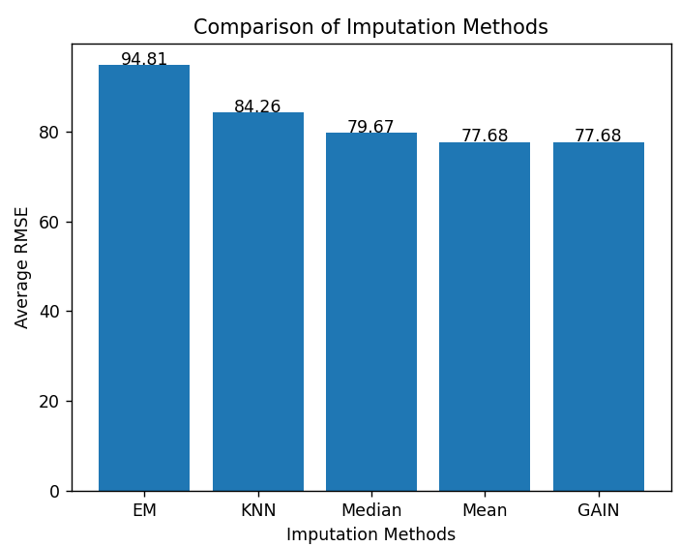
For outlier detection and treatment, various thresholds based on the Interquartile Range (IQR) were evaluated. The threshold of 0.2 times the IQR was selected as it provided a more balanced data retention compared to alternatives such as 0.25 and 0.15. For instance, a 0.25 IQR threshold would exclude height values exceeding 190 cm, which, while relatively uncommon, do not constitute outliers within the Taiwanese population. Adjusting the threshold to 0.2 IQR allowed for the exclusion of values above 200 cm, which are more likely to stem from input errors or represent extreme anomalies. This filtering strategy was operationalized by defining the acceptable data range as the interquartile interval extended by ±0.2 times the IQR(See Graph 2).
Graph 2: Each scenarios’ range
Graph 1: Imputation Methods comparison
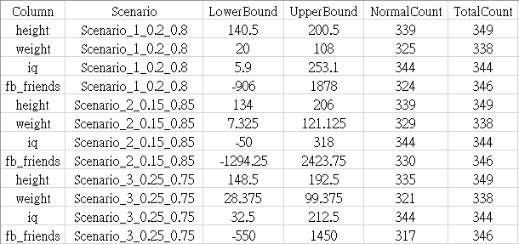
Following these preprocessing steps, the model was trained on a test set that had undergone the same imputation procedure. This led to a measurable improvement in classification accuracy, supporting the effectiveness of the preprocessing pipeline.
Notably, for the self_intro attribute, text normalization procedures were applied, including stopword removal, abbreviation expansion, elimination of punctuation and redundant whitespace, and conversion of all characters to lowercase. Spelling correction was also attempted where applicable. These preprocessing steps led to a significant enhancement in model performance, confirming their necessity in handling free-text input fields.
According to the experimental results, the all-distilroberta-v1 model outperformed other embedding methods and SBERT variants across most evaluation metrics, including accuracy and F1 score. This model compresses semantic embeddings based on the pretrained DistilRoBERTa language model, offering a balance between representational capacity and computational efficiency. It is particularly well-suited for classification tasks involving medium-sized corpora. Prior studies have also shown that this architecture delivers stable performance in sentence similarity and semantic matching tasks, and serves as a competitive baseline across various natural language understanding benchmarks [11]. Accordingly, considering both empirical performance and computational constraints, this study adopts the embeddings generated by all-distilroberta-v1 as the semantic representation for the self_intro field.

Feature Engineering
In the feature engineering phase, this study adopted a multi-pronged approach focusing on: (1) computing the correlation between each variable and the target variable gender to perform feature selection; (2) conducting feature extraction for specific variables to enhance representational capacity; and (3) evaluating feature importance using model-driven methods to quantify each feature’s contribution to the predictive task. This comprehensive strategy aims to optimize the input feature space, thereby improving both model performance and interpretability.

Reasoning process
In machine learning, excessive features can cause overfitting, reduce training efficiency, and introduce irrelevant noise. Identifying features significantly associated with the target is thus essential. Correlation analysis enables the exclusion of redundant variables and, as shown in prior studies, correlation-based filtering enhances both model simplicity and predictive performance[12].
Disparities in numerical feature scales can bias models using distance metrics or gradient descent. Normalization mitigates this by rescaling variables to a standard range. In this study, variables like height, weight, iq, fb_friends, and yt were normalized to improve model stability and convergence[13].
In NLP, converting text into vectors is necessary for semantic understanding. We used S-BERT to embed the self_intro field into 768-dimensional vectors. While these capture sentence-level semantics, high dimensionality may impair generalization and efficiency. We applied dimensionality reduction to alleviate this and enhance performance [14].
Since features contribute unequally to predictions, focusing the model on high-importance variables can improve accuracy and stability. We introduced a feature-weighting strategy based on feature importance, assuming that emphasizing key features aids learning and predictive accuracy. Similar methods have shown benefits in multi-label learning and feature selection [15]

Approaches
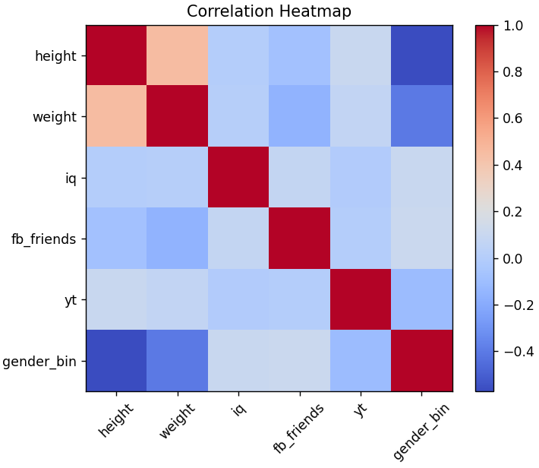
To address the heterogeneity in variable types within structured data, this study employs two tailored correlation measures for analysis. For assessing the association between numerical variables and binary categorical variables (e.g., gender), the point-biserial correlation is adopted. This measure, an extension of Pearson correlation, is suitable for quantifying linear relationships between continuous and dichotomous variables [16]. In contrast, for relationships between two nominal categorical variables (e.g., gender and star_sign or phone_os), Cramér’s V is employed. This statistic, derived from the chi-squared test, offers a standardized measure of association between categorical variables and demonstrates robustness with respect to sample size and category distribution[17]. This variable-type matching approach effectively mitigates the risk of incorrect statistical inferences due to inappropriate methodological applications.
Graph 3: Correlation Heatmap
For normalization of numerical features, Z-score normalization is applied to variables including height, weight, iq, fb_friends, and yt. This method transforms each feature to have a mean of zero and a standard deviation of one, thereby enabling comparability across different scales. The normalized features are then incorporated into various model architectures for comparative analysis. Z-score normalization has been widely used in academic literature to address feature scale heterogeneity and serves a critical role during the data preprocessing stage [18]. During experimentation, we evaluate the involvement and predictive contribution of these normalized features in the learning process, comparing results against models trained on unnormalized data.
Regarding dimensionality reduction techniques, this study utilizes two representative methods: Principal Component Analysis (PCA) and Autoencoders. PCA, a classical linear method, employs orthogonal transformation to maximize the variance captured from the original feature space and is commonly used for feature simplification and visualization tasks [19]. Conversely, the Autoencoder is a nonlinear neural network architecture capable of autonomously learning low-dimensional latent representations, making it particularly effective for capturing complex structural information in semantic embeddings [20]. These two methods, representing linear and nonlinear reduction strategies respectively, have been empirically validated for their effectiveness in high-dimensional data contexts.
To implement the proposed feature importance-based weighting strategy, feature importance scores are extracted from pre-trained models such as Gradient Boosting and Random Forest. These scores quantify the degree to which the model relies on each input variable during training. The scores are then normalized into a weight vector and applied to the original feature values via element-wise multiplication, resulting in a transformed, weighted feature space. This process is akin to a weighted feature transformation and has been shown in prior applications to enhance model sensitivity to salient features. Notably, this method does not require external annotations and relies solely on model outputs, thus offering practical value for feature selection and model refinement[21], [22].

Optimal Methods
During the correlation analysis phase, a notable negative correlation was observed between height and gender (r = -0.571), as well as between weight and gender (r = -0.404). In contrast, other variables such as fb_friends (0.116), star_sign (0.085), phone_os (0.020), and sleepness (0.020) exhibited relatively weak correlations. Based on the predefined selection threshold of |r| ≥ 0.3, only height and weight were retained as statistically significant input features. This data-driven feature selection strategy facilitates the condensation of informational content and contributes to a more streamlined and representative input space for subsequent model training(See Graph3).
Although normalization theoretically mitigates bias caused by scale disparities across features, experimental findings in this study revealed that applying Z-score normalization to the aforementioned variables did not improve model performance beyond the optimal baseline. This may be attributed to interactions among model architecture, data distribution, and other feature engineering techniques. Previous studies have similarly reported that for models insensitive to distance metrics (e.g., tree-based models), normalization may exert limited influence on performance and, in some cases, may degrade accuracy by disrupting the original data distribution. Accordingly, based on empirical observations and model behavior analysis, this study opted to retain the original, unnormalized numerical features in the final feature engineering pipeline.
Regarding dimensionality reduction, although PCA and Autoencoder are theoretically capable of reducing feature dimensionality, experimental results indicated that neither method led to improvements in predictive accuracy for downstream models. Compared to the baseline model without dimensionality reduction, it was observed that these methods potentially compressed or eliminated critical information within the original semantic embeddings, thereby impairing classification performance. Supporting literature also notes that when semantic embeddings already possess high informational density and the downstream model is not sensitive to high dimensionality, dimensionality reduction may not only be unhelpful but may also adversely impact performance. Consequently, this study excluded the dimensionality reduction step and retained the original semantic vectors as model inputs to preserve information richness and maximize predictive outcomes.
Although the theoretical foundation of feature importance suggests its potential to enhance the identification of salient features, experimental results from this study showed no performance gains over our best record. Further analysis suggests that in contexts where feature distributions are balanced and their associations with the target variable are well-defined, applying additional weighting may disrupt the existing informational structure, leading to model drift. Related literature also highlights that the efficacy of feature importance is highly contingent on the collinearity structure among variables and the underlying nonlinearity of the data. Therefore, based on comprehensive empirical findings and evaluation of model behavior, this study ultimately discarded the feature importance strategy and reverted to the use of the unweighted original feature space for optimal predictive performance.

Classifier

Reasoning process
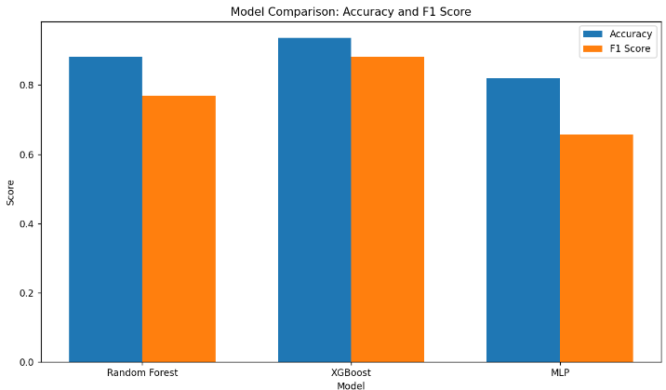
During the model implementation phase, we evaluated the performance of various machine learning and deep learning algorithms. For machine learning, Random Forest and XGBoost were selected due to their established effectiveness in classification tasks. In parallel, we also experimented with deep learning models, including Multi-Layer Perceptron (MLP) neural architectures. While all of these methods are theoretically supported in classification literature, the small size of our dataset and the limited number of features led us to prioritize machine learning models for their efficiency and interpretability[23], [24].
Graph 4: Correlation Heatmap
To optimize training performance, we employed automated hyperparameter tuning methods, including GridSearchCV and Bayesian optimization. Model selection was conducted using five-fold cross-validation to ensure robust parameter configurations[25].
Regarding the validation set, although existing studies commonly allocate 20% of the training data for validation, we opted for a 30% validation split[26]. This decision was made to mitigate overfitting, particularly given the limited number of features used in our modeling process. Previous literature has demonstrated that increasing the validation ratio to 30% can effectively reduce overfitting in scenarios involving small-scale datasets, thereby enhancing model generalization[27].

Approaches
In this study, we explored several hyperparameter optimization strategies, including traditional GridSearchCV and Bayesian Optimization. Experimental results indicated that both methods yielded comparable performance, with no substantial difference in accuracy.
Further refinements were made to the XGBoost model by applying feature selection to mitigate overfitting. Specifically, the top 150 features ranked by importance were used as model inputs, based on the assumption that including less informative features might negatively influence classification outcomes. Comparative tests with the top 100 and top 200 features revealed that both alternatives led to decreased accuracy, suggesting that selecting the top 150 features offered an optimal balance between complexity and performance[28].
Although we conducted preliminary tests using deep learning models, they exhibited inferior training efficiency and predictive performance on this small-scale dataset compared to machine learning approaches. As a result, deep learning was not adopted as the primary modeling strategy.
Moreover, we examined the impact of varying the test set size by experimenting with validation splits of 0.2, 0.3, and 0.4. While a 0.4 split yielded the highest validation accuracy, it also introduced instability in final performance, indicative of overfitting. Similarly, the 0.2 split was associated with overfitting issues upon submission[29]. Consequently, a 0.3 split was selected to strike a balance between validation performance and model generalizability[30].Optimal Methods
The most effective configuration in this study involved setting the validation set proportion to 0.3, which served to mitigate the risks of both overfitting and underfitting while enhancing model generalization. For the classification task, XGBoost was employed as the primary model. To further stabilize predictions, we selected the top 150 features based on feature importance rankings, thereby reducing the influence of low-importance features that could potentially introduce noise and lead to erroneous model judgments.(See Graph 4)
Hyperparameter tuning was performed using GridSearchCV with five-fold cross-validation to identify the optimal parameter configuration. The final trained model was then applied to the test set to generate predictions and facilitate performance evaluation.

Conclusion
This study presented a comparative analysis of various data imputation techniques, supplemented by the application of feature selection and feature importance to refine model input configurations. Experimental findings indicate that while emerging approaches—such as Multi-Layer Perceptron (MLP)—may demonstrate advantages under certain conditions, particularly in handling high-dimensional features, no single method consistently outperforms others when applied to real-world datasets characterized by variability and noise.
Furthermore, the pursuit of data completeness through imputation remains a symptomatic remedy rather than a fundamental solution. Future research should consider hybrid imputation strategies and adaptive mechanisms that dynamically respond to data characteristics. Bridging theoretical robustness with practical adaptability is essential in navigating increasingly complex and large-scale datasets, thereby avoiding reliance on superficially promising yet structurally weak methodologies.

WORK DIVISION
Name | Work description | Contribution
Rogers zheng | - Experimental Design  - Literature Review  - Data Imputation  - Model Training  - Documentation | 50%
Brian Zou  Graph 6: Comparison of Model | - Experimental Design  - Literature Review  - Model Training  - Documentation | 50%

REFERENCES
[1] “(PDF) Handling Outlier Data as Missing Values by Imputation Methods: Application of Machine Learning Algorithms,” ResearchGate, Oct. 2024, Accessed: Apr. 05, 2025. [Online]. Available: https://www.researchgate.net/publication/358565692_Handling_Outlier_Data_as_Missing_Values_by_Imputation_Methods_Application_of_Machine_Learning_Algorithms
[2] “Diabetes classification application with efficient missing and outliers data handling algorithms | Complex & Intelligent Systems.” Accessed: Apr. 05, 2025. [Online]. Available: https://link.springer.com/article/10.1007/s40747-021-00349-2
[3] J. Yoon, J. Jordon, and M. van der Schaar, “GAIN: Missing Data Imputation using Generative Adversarial Nets,” Jun. 07, 2018, arXiv: arXiv:1806.02920. doi: 10.48550/arXiv.1806.02920.
[4] M. Usmani, Z. A. Memon, A. Zulfiqar, and R. Qureshi, “Preptimize: Automation of Time Series Data Preprocessing and Forecasting,” Algorithms, vol. 17, no. 8, Art. no. 8, Aug. 2024, doi: 10.3390/a17080332.
[5] Ch. S. K. Dash, A. K. Behera, S. Dehuri, and A. Ghosh, “An outliers detection and elimination framework in classification task of data mining,” Decis. Anal. J., vol. 6, p. 100164, Mar. 2023, doi: 10.1016/j.dajour.2023.100164.
[6] Q. Jiao and S. Zhang, “A Brief Survey of Word Embedding and Its Recent Development,” in 2021 IEEE 5th Advanced Information Technology, Electronic and Automation Control Conference (IAEAC), Mar. 2021, pp. 1697–1701. doi: 10.1109/IAEAC50856.2021.9390956.
[7] C. Wang, J. Caja, and E. Gómez, “Comparison of methods for outlier identification in surface characterization,” Measurement, vol. 117, pp. 312–325, Mar. 2018, doi: 10.1016/j.measurement.2017.12.015.
[8] L. Silva et al., “Outliers Treatment to Improve the Recognition of Voice Pathologies,” Procedia Comput. Sci., vol. 164, pp. 678–685, Jan. 2019, doi: 10.1016/j.procs.2019.12.235.
[9] P. Nair and I. Kashyap, “Hybrid Pre-processing Technique for Handling Imbalanced Data and Detecting Outliers for KNN Classifier,” in 2019 International Conference on Machine Learning, Big Data, Cloud and Parallel Computing (COMITCon), Feb. 2019, pp. 460–464. doi: 10.1109/COMITCon.2019.8862250.
[10] N. Reimers and I. Gurevych, “Sentence-BERT: Sentence Embeddings using Siamese BERT-Networks,” in Proceedings of the 2019 Conference on Empirical Methods in Natural Language Processing and the 9th International Joint Conference on Natural Language Processing (EMNLP-IJCNLP), K. Inui, J. Jiang, V. Ng, and X. Wan, Eds., Hong Kong, China: Association for Computational Linguistics, Jan. 2019, pp. 3982–3992. doi: 10.18653/v1/D19-1410.
[11] Y. Goldberg and O. Levy, “word2vec Explained: deriving Mikolov et al.’s negative-sampling word-embedding method,” Feb. 15, 2014, arXiv: arXiv:1402.3722. doi: 10.48550/arXiv.1402.3722.
[12] M. A. Hall, “Correlation-based Feature Selection for Discrete and Numeric Class Machine Learning”.
[13] D. U. Ozsahin, M. Taiwo Mustapha, A. S. Mubarak, Z. Said Ameen, and B. Uzun, “Impact of feature scaling on machine learning models for the diagnosis of diabetes,” in 2022 International Conference on Artificial Intelligence in Everything (AIE), Aug. 2022, pp. 87–94. doi: 10.1109/AIE57029.2022.00024.
[14] G. T. Reddy et al., “Analysis of Dimensionality Reduction Techniques on Big Data,” IEEE Access, vol. 8, pp. 54776–54788, 2020, doi: 10.1109/ACCESS.2020.2980942.
[15] A. Altmann, L. Toloşi, O. Sander, and T. Lengauer, “Permutation importance: a corrected feature importance measure,” Bioinformatics, vol. 26, no. 10, pp. 1340–1347, May 2010, doi: 10.1093/bioinformatics/btq134.
[16] D. G. Bonett, “Point‐biserial correlation: Interval estimation, hypothesis testing, meta‐analysis, and sample size determination,” Br. J. Math. Stat. Psychol., vol. 73, no. S1, pp. 113–144, Nov. 2020, doi: 10.1111/bmsp.12189.
[17] M. Zámková, M. Prokop, and R. Stolín, “Monitoring students’ success rate in college statistics with categorical data analysis,” presented at the INTERNATIONAL CONFERENCE OF NUMERICAL ANALYSIS AND APPLIED MATHEMATICS ICNAAM 2019, Rhodes, Greece, 2020, p. 420053. doi: 10.1063/5.0026575.
[18] S. M. T. Ayatollahi, “Age standardization of weight-for-height in children using a unified Z-score method,” Ann. Hum. Biol., Jan. 1995, doi: 10.1080/03014469500003802.
[19] R. Drikvandi and O. Lawal, “Sparse Principal Component Analysis for Natural Language Processing,” Ann. Data Sci., vol. 10, no. 1, pp. 25–41, Feb. 2023, doi: 10.1007/s40745-020-00277-x.
[20] P. Vincent, H. Larochelle, Y. Bengio, and P.-A. Manzagol, “Extracting and composing robust features with denoising autoencoders,” in Proceedings of the 25th international conference on Machine learning - ICML ’08, Helsinki, Finland: ACM Press, 2008, pp. 1096–1103. doi: 10.1145/1390156.1390294.
[21] L. Breiman, “Random Forests,” Mach. Learn., vol. 45, no. 1, pp. 5–32, Oct. 2001, doi: 10.1023/A:1010933404324.
[22] J. H. Friedman, “Greedy Function Approximation: A Gradient Boosting Machine,” Ann. Stat., vol. 29, no. 5, pp. 1189–1232, 2001.
[23] V. Borisov, T. Leemann, K. Seßler, J. Haug, M. Pawelczyk, and G. Kasneci, “Deep Neural Networks and Tabular Data: A Survey,” IEEE Trans. Neural Netw. Learn. Syst., vol. 35, no. 6, pp. 7499–7519, Jun. 2024, doi: 10.1109/TNNLS.2022.3229161.
[24] R. Shwartz-Ziv and A. Armon, “Tabular data: Deep learning is not all you need,” Inf. Fusion, vol. 81, pp. 84–90, May 2022, doi: 10.1016/j.inffus.2021.11.011.
[25] “NeurIPS Poster Better by default: Strong pre-tuned MLPs and boosted trees on tabular data.” Accessed: Apr. 05, 2025. [Online]. Available: https://neurips.cc/virtual/2024/poster/96765
[26] “Assessing the predictive capability of ensemble tree methods for landslide susceptibility mapping using XGBoost, gradient boosting machine, and random forest | Discover Applied Sciences.” Accessed: Apr. 05, 2025. [Online]. Available: https://link.springer.com/article/10.1007/s42452-020-3060-1
[27] F. Ramdani and M. T. Furqon, “The simplicity of XGBoost algorithm versus the complexity of Random Forest, Support Vector Machine, and Neural Networks algorithms in urban forest classification,” F1000Research, vol. 11, p. 1069, Sep. 2022, doi: 10.12688/f1000research.124604.1.
[28] K. Yang, L. Liu, and Y. Wen, “The impact of Bayesian optimization on feature selection,” Sci. Rep., vol. 14, no. 1, p. 3948, Feb. 2024, doi: 10.1038/s41598-024-54515-w.
[29] S. Demir and E. K. Şahin, “Liquefaction prediction with robust machine learning algorithms (SVM, RF, and XGBoost) supported by genetic algorithm-based feature selection and parameter optimization from the perspective of data processing,” Environ. Earth Sci., vol. 81, no. 18, p. 459, Sep. 2022, doi: 10.1007/s12665-022-10578-4.
[30] “A XGBoost risk model via feature selection and Bayesian hyper-parameter optimization | Request PDF,” ResearchGate. Accessed: Apr. 05, 2025. [Online]. Available: https://www.researchgate.net/publication/330617636_A_XGBoost_risk_model_via_feature_selection_and_Bayesian_hyper-parameter_optimization

